MST TX Quarterly Report
September – November 2023
FY24

Table of Contents

What is Multisystemic Therapy……………………….…………………………………………………………………………….…... 3
MSTS role in the MST Texas Project ………………………………………………………………………………………………….. 3
EBA’s role in the MST Texas Project……………………………………………………………………………………………………. 3
Overview: FY23 Multi-Systemic Therapy in Texas……………………………………………………………………………….. 4
Texas Service Directory and Provider Map .............................................................................................. 4
Q1 Overview ………………………………………………………………………………………………………………………………………. 5
Program Development ……………………………….……………………………………….….…………………………………………. 7
- Bluebonnet Trails Community Services
- Denton MHMR Center
- Hill Country MHDD Center
- LifePath Systems
- North Texas Behavioral Health
- StarCare Specialty Health System
- Tropical Texas Behavioral Health
Referrals and Utilization.……………………………….......................................................................................... 8
QMHP Allowability in Texas……………………………………………………………………………………………………………….. 11
Texas Expansion…………………………………………………………………………………………………………………………………. 11
Anticipatory FY24 Activities and Highlights............................................................................................. 11

What is Multisystemic Therapy
MST is an intensive family- and community-based treatment that addresses the multiple influences that contribute to serious antisocial or illegal behavior in youth aged 12 -17 years. The MST approach views individuals as being part of, and influenced by, a complex network of interconnected systems that encompass individual, family, and extrafamilial (peer, school, neighborhood) factors. In MST, this “ecology” of interconnected systems is viewed as the “client.” To achieve successful outcomes with these youth, interventions are generally necessary within and among a combination of these systems. MST treatment typically lasts from 3 to 5 months (average of 4 months) and caseloads range from 4 to 6 families (average of 5 families). Caseload size may be impacted by such characteristics as the intensity of services based on clinical, average time of the cases in treatment on a caseload (newer cases require significantly more time), number of youths in the home with problems and the relative complexity of the youth’s behavior (e.g., youth with multiple distinct referral behaviors).

MST Service’s role in the MST Texas Project
The MST Services (MSTS) team preserves the integrity of the treatment model, thereby ensuring the best possible outcomes for the youth and families treated. MST Services maintains licensing agreements with all MST provider organizations, provides training and quality assurance procedures, in addition to leadership and support in program start-up/expansion, program adherence, program development, and adherent implementation of MST to obtain have accountability for program outcomes. In Texas, MST Services employs three (3) experts and two (2) program developers, whose roles and functions are described above.

EBA’s role in the MST Texas Project
Evidence Based Associates (EBA) helps visionary leaders implement evidence-based programs using effective strategies to achieve socially significant impacts. To help agencies achieve greater impact in delivering meaningful social services, EBA provides hiring and recruitment support, implementation support, communication consultations, quality assurance, referral management and maximization support, in addition to ongoing project management services that foster the success of proven interventions and programs. In Texas, EBA provides a full-time project director and recruiter to aid in the success of the MST Texas Project.

Overview: FY23 Multi-Systemic Therapy in Texas
In the summer of 2022, through Executive Action, funding was provided through a competitive process for seven Local Mental Health Authorities (LMHAs) across Texas to begin implementing Multisystemic Therapy (MST). By the end of FY23, Texas received approximately 200 referrals from multiple child-serving referring entities. Out of those approximate referrals, seven (7) funded and participating local mental health authorities were able to serve 100 families with Multisystemic Therapy from January 2023 – September 2023. The recruitment of qualified family intervention specialists to provide MST services to youth and families was a challenge; although the fiscal year ended at 78% of the available positions being fully staffed. Of the 100 families served, 92 children received services and were discharged by end of FY23. The MST Texas Project team continues to gain significant momentum. LMHA’s across the state, MST Services, Evidence-Based Associates, Meadows Mental Health Policy Institute, and HHSC continue to work together to increase MST’s presence across the state. Texas currently has a capacity to provide MST Services to approximately 162 at-risk youth and families each year when fully staffed.

Texas Service Directory and Provider Map
The MST Texas Project would not have the growth it has today without tireless efforts of collaborative work across multiple layers of Texas leadership. Below, is a list of those committed to service the Texas MST youth and families thus far:
- Texas Health and Human Services Commission Contact Us | Texas Health and Human Services
- MST Services Contact Us About Programs for Troubled Youth | MST Services
- Evidence-Based Associates Texas | Evidence Based Associates
- Meadows Mental Health Policy Institute Contact – MMHPI – Meadows Mental Health Policy Institute
- Bluebonnet Trails Community Services MultiSystemic Therapy Program | Bluebonnet Trails (bbtrails.org)
- Denton MHMR Center Child & Adolescent Services – Denton County – MHMR Center (dentonmhmr.org)
- Hill Country MHDD Center Hill Country MHDD Centers
- LifePath Systems Youth & Family Services – LifePath Systems
- North Texas Behavioral Health NTBHA - North Texas Behavioral Health Authority
- StarCare Specialty Health System StarCare Lubbock | Specialty Health System
- Tropical Texas Behavioral Health Tropical Texas Behavioral Health (ttbh.org)

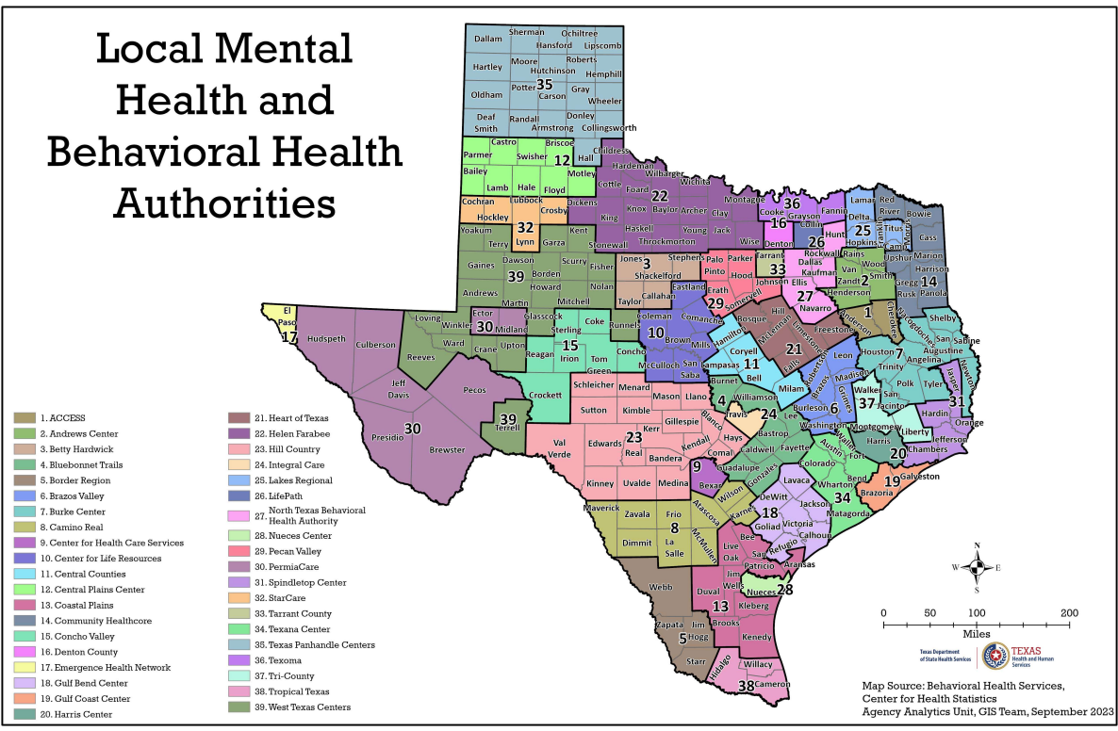

Overview: Quarter 1 (September 1 – November 30)
As of September 1, 2023, the MST Texas Project continues to gain momentum. An estimated 119 families were served during the reporting period, 49 of those cases were discharged, and 70 cases remain open while continuing to receive ongoing MST Services. Texas increased to 85% fully staffed during this quarter leaving three of 27 positions remaining open. Each Family Intervention Specialist (FIS) has an estimated average of three intensive cases each with an anticipation to reach five cases per FIS by July 2024. July 2024 will be one full year of operation with all seven LMHA’s open and serving youth and families with this evidence-based model.

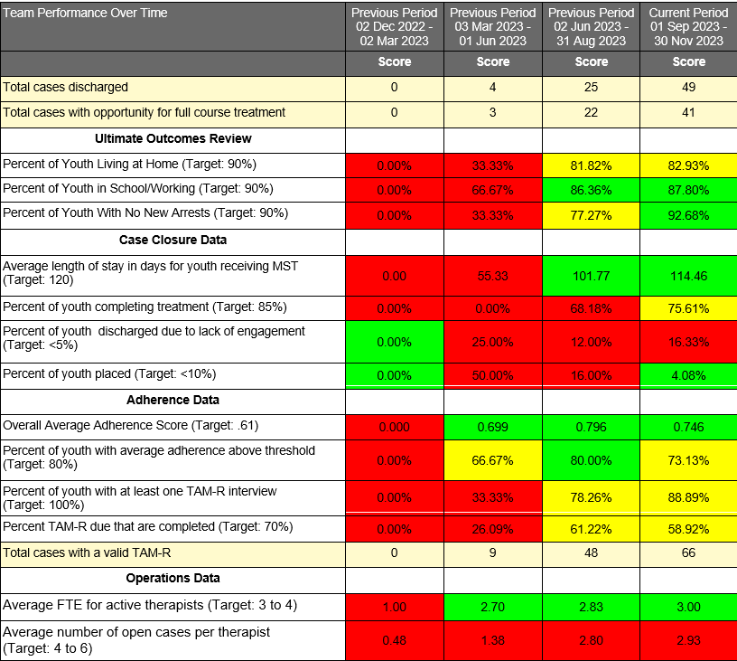

MST Services continues to train new staff to ensure treatment adherence is optimal. Stringent quality assurance measures are ongoing to include but is not limited to orientation training, weekly case consultation with an MST Expert, weekly clinical supervision for treatment teams and supervisors, and quarterly booster trainings. Each month, MST Services facilitates the monitoring of quality by conducting monthly surveys (TAM-R adherence measures) of client families to ensure that MST is being delivered as intended. Research on MST continues to demonstrate a strong correlation between following the principles and processes of MST to obtaining positive client outcomes.

Program Development
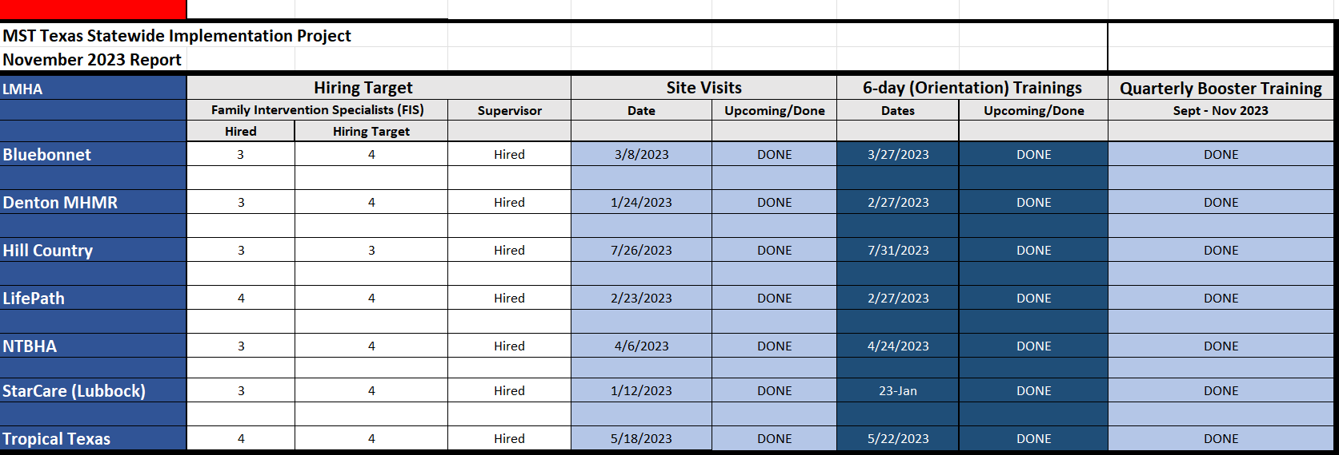
Bluebonnet: has completed 2 boosters (one combined with Hill country) and is scheduled for their second booster in the first quarter of 2024.

Denton: has completed 2 combined boosters and are scheduled for their third booster training in the first quarter of 2024.

Hill Country: has completed 1 booster (combined with Bluebonnet) and is scheduled for their second booster in the first quarter of 2024.

Lifepath: has completed 2 combined boosters and are scheduled for their third booster training in the first quarter of 2024.

NTBHA: has completed 2 boosters and is scheduled for their third booster in the first quarter of 2024.

StarCare: has completed 2 boosters (one virtual and one in person) and is scheduled for their third booster in the first quarter of 2024.

Tropical Tx: has completed 1 booster and is scheduled for their second booster in the first quarter of 2024.

Referrals and Utilization
The referral trend below represents the number of referrals received in Q1/ September – November 2023 of FY24. 114 referrals were received during Q1/ FY24.
Referral- A youth/family that has been submitted to the MST Supervisor for screening of MST inclusionary and exclusionary criteria.

The referral trend below represents the number of referrals received by quarter since the beginning of the MST Texas project. 325 total referrals have been received.

The chart below represents the number of cases served in Q1/ September – November 2023 of FY24. Some cases may have been served during more than one quarter. MST treatment typically lasts from 3 to 5 months (average of 4 months). 119 cases were served in Q1/FY24.
Cases served: A youth/family that is currently enrolled or has been clinically discharged during the reporting period.

The chart below represents the number of cases served by quarter since the beginning of the MST Texas project. Some cases may have been served during more than one quarter. MST treatment typically lasts from 3 to 5 months (average of 4 months).

The chart below represents the number of cases discharged in Q1/ September – November 2023 of FY24.
Discharge: Discharge is based upon evidence from multiple sources (i.e., parent, school, probation officer, etc.). The MST Supervisor with support of MST Services determines when the overarching goals have been met.

The chart below represents the number of cases discharged each quarter.
78 cases have been clinically closed since the beginning of the MST Texas project.

QMHP Allowability
On September 15, 2023, the Texas Health and Human Services Commission released a broadcast message in notification to the seven LMHA’s for an opportunity to expand hiring potential. It was determined that the provision of some MST activities is allowable using QMHPs. HHSC recommends that the providers consult with the MST Expert regarding recruitment and screening of a QMHP. MST recommends master’s level QMHPs to perform the activities outlined in the MST Model and as the Statement of Work refers to the MST Model for delivery of services, although a bachelor’s level QMHP may be considered. The determination of QMHP allowability was concluded after a preceding development in collaboration from The Meadows Mental Health Policy Institute (Meadows Institute), MST Services, and Evidence-Based Associates (EBA).

Texas Expansion
Three of the original seven funded Texas providers recognized an increase in demand for MST which exceeded the program's original capacity. In October 2023, all three providers were notified of being an apparent awardee of additional funding to expand by HHSC.
Sixteen total providers were among notification of that funding announcement. FY24 will include a total of 22 MST teams, with 16 providers.
Local Mental Health and Behavioral Health Authority: 16 – Betty Hardwick, Bluebonnet Trails, Center for Health Care Services (2 teams), Central Counties, Denton County, Gulf Coast Center, Harris Center, Hill Country, LifePath (2 teams), North Texas Behavioral Health Authority (3 teams), PermiaCare, StarCare, Spindletop, Tarrant County (2 Teams), Tri-County, and Tropical Texas (2 teams)

Anticipatory FY24 Activities and Highlights
Stages of the MST Program Development method is underway. Providers are in the process of receiving feasibility considerations, key consultative, and implementation services from MST Services and Evidence-Based Associates in preparation for successful team start up. Each provider will receive ample support from MST Services and Evidence-Based Associates throughout all six stages of program implementation and the duration of the team’s existence.

