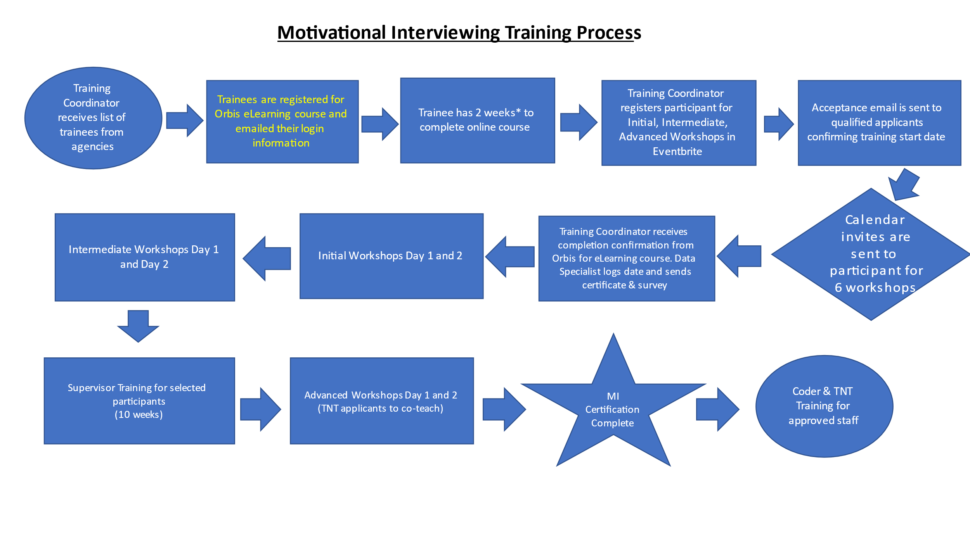
*The time needed for completion of the online course may vary by participant.

