Service Area Form
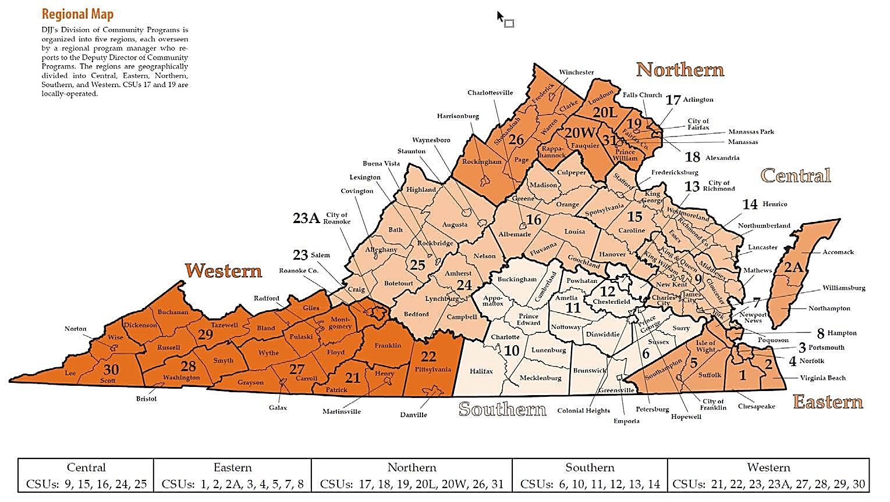
DSP Name: Date:
Please list the office locations below or attach a list of all locations.
Office Location: __________________ Phone: ______ ____
Staff/ Referral Contact: ______________ Email: ___________
Office Location: _________________ Phone: ______ ____
Staff/ Referral Contact: _______________ Email: __________
Office Location: ______________ Phone: __________
Staff/ Referral Contact: ____________ Email: _________
Service Areas
If services are provided statewide to each court service unit and county, please check the box and list the service provided across the state.
☐ Statewide Provision of Services: _ .
If services are provided by region (either by court service unit or individual counties) from regional offices, please complete the following checklist for each Service Type and Region.
CHECK YES for the CSU and area where the agency provides services consistently.
CHECK LIMITED where services may be provided on a case by case basis (i.e. agency staff may be able to travel to provide the service, as it neighbors the current service area).

Please complete multiple Forms to capture additional service types.
SERVICES OFFERED: ____ __ __ __ _

Central Region ☐ ALL CENTRAL
CSU | County/City | YES | Limited
9th | Charles City | ☐ | ☐
9th | Gloucester/ Poquoson | ☐ | ☐
9th | James City | ☐ | ☐
9th | King & Queen | ☐ | ☐
9th | King William | ☐ | ☐
9th | Matthews | ☐ | ☐
9th | Middlesex | ☐ | ☐
9th | New Kent | ☐ | ☐
9th | Williamsburg | ☐ | ☐
9th | York | ☐ | ☐
15th | Caroline | ☐ | ☐
15th | Essex | ☐ | ☐
15th | Fredericksburg | ☐ | ☐
15th | Hanover | ☐ | ☐
15th | King George | ☐ | ☐
15th | Lancaster | ☐ | ☐
15th | Northumberland | ☐ | ☐
15th | Richmond County | ☐ | ☐
15th | Spotsylvania | ☐ | ☐
15th | Stafford | ☐ | ☐
15th | Westmoreland | ☐ | ☐
16th | Albemarle | ☐ | ☐
16th | Charlottesville | ☐ | ☐
16th | Culpeper | ☐ | ☐
16th | Fluvanna | ☐ | ☐
16th | Goochland | ☐ | ☐
16th | Greene | ☐ | ☐
16th | Louisa | ☐ | ☐
16th | Madison | ☐ | ☐
16th | Orange | ☐ | ☐
24th | Amherst | ☐ | ☐
24th | Bedford | ☐ | ☐
24th | Campbell | ☐ | ☐
24th | Lynchburg | ☐ | ☐
24th | Nelson | ☐ | ☐
25th | Allegheny | ☐ | ☐
25th | Augusta/ Covington | ☐ | ☐
25th | Bath | ☐ | ☐
25th | Botetourt | ☐ | ☐
25th | Buena Vista/ Rockbridge | ☐ | ☐
25th | Craig | ☐ | ☐
25th | Lexington | ☐ | ☐
25th | Highland | ☐ | ☐
25th | Staunton | ☐ | ☐
25th | Waynesboro | ☐ | ☐

Eastern Region ☐ ALL EASTERN
 | CSU | County/City |  | YES | Limited
 | 1st | Chesapeake | ☐ |  | ☐
 | 2-A | Accomac | ☐ |  | ☐
 | 2-A | Northampton | ☐ |  | ☐
 | 2nd | Portsmouth | ☐ |  | ☐
 | 3nd | Virginia Beach | ☐ |  | ☐
 | 5th | Franklin | ☐ |  | ☐
5th |  | Isle of Wight |  | ☐ | ☐
5th |  | Norfolk |  | ☐ | ☐
5th |  | Southampton |  | ☐ | ☐
5th |  | Suffolk |  | ☐ | ☐
7th |  | Newport News |  | ☐ | ☐
8th |  | Hampton |  | ☐ | ☐

Northern Region ☐ ALL NORTH
CSU | County/City | YES | Limited
17th | Arlington | ☐ | ☐
17th | Falls Church | ☐ | ☐
18th | Alexandria | ☐ | ☐
19th | Fairfax | ☐ | ☐
20-L | Loudon | ☐ | ☐
20-W | Fauquier | ☐ | ☐
20-W | Rappahannock | ☐ | ☐
26th | Clarke | ☐ | ☐
26th | Frederick | ☐ | ☐
26th | Harrisonburg | ☐ | ☐
26th | Page | ☐ | ☐
26th | Rockingham | ☐ | ☐
26th | Shenandoah | ☐ | ☐
26th | Warren | ☐ | ☐
26th | Winchester | ☐ | ☐
31st | Manassas | ☐ | ☐
31st | Prince William | ☐ | ☐

Western Region ☐ ALL WESTERN
CSU | County/City | YES | Limited
21st | Martinsville | ☐ | ☐
21st | Henry | ☐ | ☐
21st | Patrick | ☐ | ☐
22nd | Danville | ☐ | ☐
22nd | Franklin | ☐ | ☐
22nd | Pittsylvania | ☐ | ☐
23-A | Roanoke | ☐ | ☐
23rd | Salem | ☐ | ☐
23rd | Roanoke | ☐ | ☐
27th | Carroll | ☐ | ☐
27th | Galax | ☐ | ☐
27th | Radford | ☐ | ☐
27th | Floyd | ☐ | ☐
27th | Grayson | ☐ | ☐
27th | Montgomery | ☐ | ☐
27th | Pulaski | ☐ | ☐
27th | Wythe | ☐ | ☐
28th | Bristol | ☐ | ☐
28th | Smyth | ☐ | ☐
28th | Washington | ☐ | ☐
29th | Bland | ☐ | ☐
29th | Buchanan | ☐ | ☐
29th | Dickenson | ☐ | ☐
29th | Giles | ☐ | ☐
29th | Russell | ☐ | ☐
29th | Tazewell | ☐ | ☐
30th | Lee | ☐ | ☐
30th | Norton | ☐ | ☐
30th | Scott | ☐ | ☐
30th | Wise | ☐ | ☐

Southern Region ☐ ALL SOUTHERN
CSU | County/City | YES | Limited
6th | Brunswick | ☐ | ☐
6th | Emporia | ☐ | ☐
6th | Hopewell | ☐ | ☐
6th | Greensville | ☐ | ☐
6th | Prince George | ☐ | ☐
6th | Surry | ☐ | ☐
6th | Sussex | ☐ | ☐
10th | Appomattox | ☐ | ☐
10th | Buckingham | ☐ | ☐
10th | Charlotte | ☐ | ☐
10th | Cumberland | ☐ | ☐
10th | Halifax | ☐ | ☐
10th | Lunenburg | ☐ | ☐
10th | Mecklenburg | ☐ | ☐
10th | Prince Edward | ☐ | ☐
11th | Amelia | ☐ | ☐
11th | Dinwiddie | ☐ | ☐
11th | Nottoway | ☐ | ☐
11th | Petersburg | ☐ | ☐
11th | Powhatan | ☐ | ☐
12th | Chesterfield | ☐ | ☐
12th | Colonial Heights | ☐ | ☐
13th | Richmond | ☐ | ☐
14th | Henrico | ☐ | ☐

