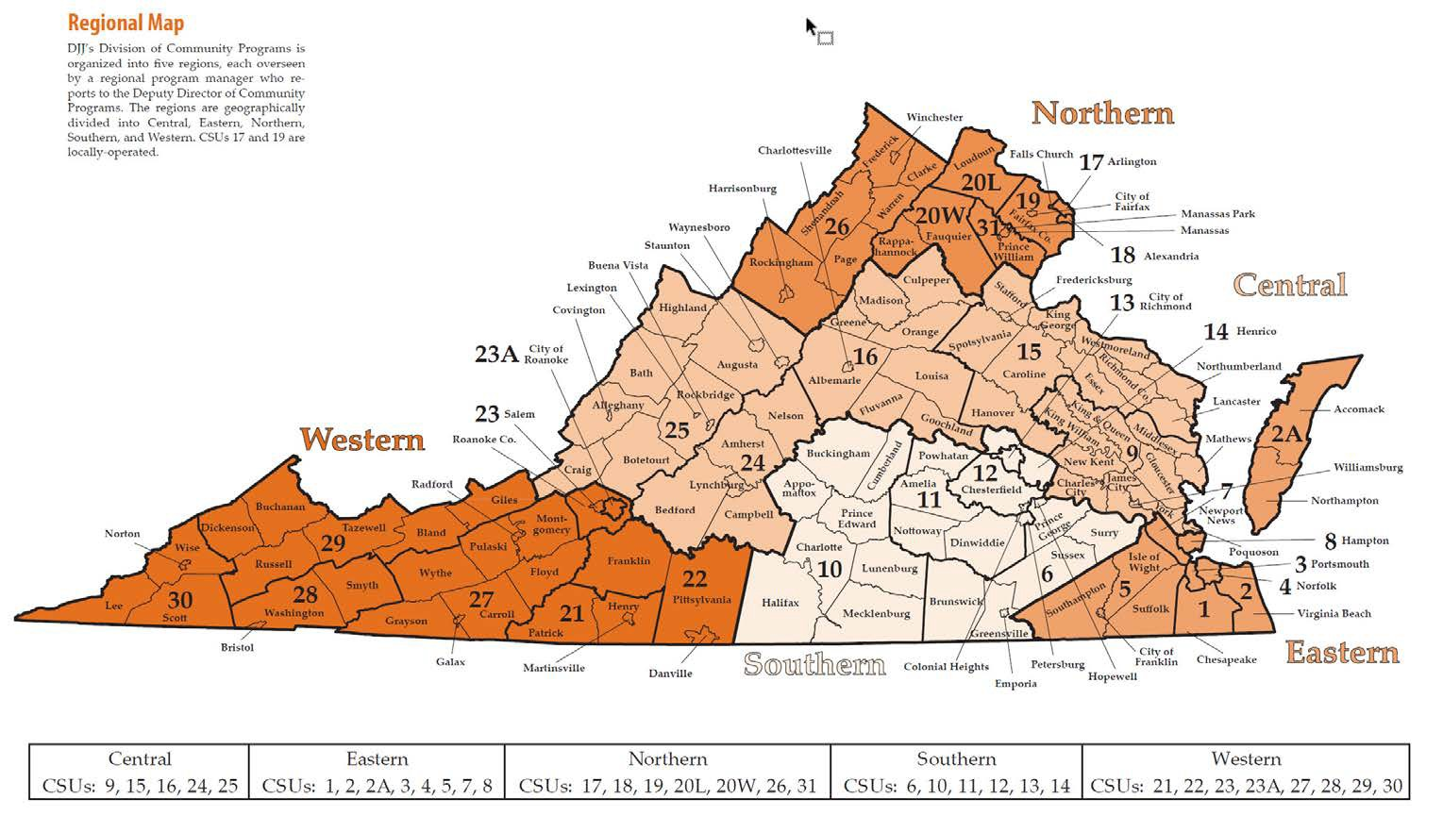
DSP Name: ____________________
Service Areas
If you will provide services statewide to every court service unit district and every individual jurisdiction, check the box below that indicates statewide provision of services. (You do not need to complete any additional sheets if you are providing services statewide.)
☐ Statewide Provision of Services ____________________
If you are providing services by regions (either by court service unit or to an individual jurisdictions) then you must complete the following checklist. CHECK YES on the CSU county or city where you are currently able to provide services and check LIMITED where you may be able provide services (for example, if you are able to provided limited support or may be able to travel please indicated limited).

Services offered: ____________________
Feel free to complete more than on DSP Service Area Form to capture additional service types or programs.

Northern

CSU | County/City | YES | Limited
17th | Arlington | ☐ | ☐
17th | Falls Church | ☐ | ☐
18th | Alexandria | ☐ | ☐
19th | Fairfax | ☐ | ☐
20-L | Loudon | ☐ | ☐
20-W | Fauquier | ☐ | ☐
20-W | Rappahannock | ☐ | ☐
26th | Clarke | ☐ | ☐

CSU | County/City | YES | Limited
26th | Frederick | ☐ | ☐
26th | Harrisonburg | ☐ | ☐
26th | Page | ☐ | ☐
26th | Rockingham | ☐ | ☐
26th | Shenandoah | ☐ | ☐
26th | Warren | ☐ | ☐
26th | Winchester | ☐ | ☐
31st | Manassas | ☐ | ☐
31st | Prince William | ☐ | ☐

Central Region

CSU | County/City | YES | Limited
9th | Charles City | ☐ | ☐
9th | Gloucester | ☐ | ☐
9th | James City | ☐ | ☐
9th | King & Queen | ☐ | ☐
9th | King William | ☐ | ☐
9th | Matthews | ☐ | ☐
9th | Middlesex | ☐ | ☐
9th | New Kent | ☐ | ☐
9th | Poquoson | ☐ | ☐
9th | Williamsburg | ☐ | ☐
9th | York | ☐ | ☐
15th | Caroline | ☐ | ☐
15th | Essex | ☐ | ☐
15th | Fredericksburg | ☐ | ☐
15th | Hanover | ☐ | ☐
15th | King George | ☐ | ☐
15th | Lancaster | ☐ | ☐
15th | Northumberland | ☐ | ☐
15th | Richmond | ☐ | ☐
15th | Spotsylvania | ☐ | ☐
15th | Stafford | ☐ | ☐
15th | Westmoreland | ☐ | ☐
16th | Albemarle | ☐ | ☐
16th | Charlottesville | ☐ | ☐
CSU | County/City | YES | Limited
16th | Culpeper | ☐ | ☐
16th | Fluvanna | ☐ | ☐
16th | Goochland | ☐ | ☐
16th | Greene | ☐ | ☐
16th | Louisa | ☐ | ☐
16th | Madison | ☐ | ☐
16th | Orange | ☐ | ☐
24th | Amherst | ☐ | ☐
24th | Bedford | ☐ | ☐
24th | Campbell | ☐ | ☐
24th | Lynchburg | ☐ | ☐
24th | Nelson | ☐ | ☐
25th | Allegheny | ☐ | ☐
25th | Augusta | ☐ | ☐
25th | Bath | ☐ | ☐
25th | Botetourt | ☐ | ☐
25th | Buena Vista | ☐ | ☐
25th | Covington | ☐ | ☐
25th | Craig | ☐ | ☐
25th | Lexington | ☐ | ☐
25th | Highland | ☐ | ☐
25th | Staunton | ☐ | ☐
25th | Rockbridge | ☐ | ☐
25th | Waynesboro | ☐ | ☐

Western Region

CSU | County/City | YES | Limited
21st | Martinsville
21st | Henry
21st | Patrick
22nd | Danville
22nd | Franklin
22nd | Pittsylvania
23-A | Roanoke
23rd | Salem
23rd | Roanoke
27th | Carroll
27th | Galax
27th | Radford
27th | Floyd
27th | Grayson
27th | Montgomery
CSU | County/City | YES | Limited
27th | Pulaski
27th | Wythe
28th | Bristol
28th | Smyth
28th | Washington
29th | Bland
29th | Buchanan
29th | Dickenson
29th | Giles
29th | Russell
29th | Tazewell
30th | Lee
30th | Norton
30th | Scott
30th | Wise

*Southern

 | CSU | County/City | YES | Limited
 | 6th | Brunswick | ☐ | ☐
 | 6th | Emporia | ☐ | ☐
 | 6th | Hopewell | ☐ | ☐
 | 6th | Greensville | ☐ | ☐
 | 6th | Prince George | ☐ | ☐
 | 6th | Surry | ☐ | ☐
 | 6th | Sussex | ☐ | ☐
 | 10th | Appomattox | ☐ | ☐
 | 10th | Buckingham | ☐ | ☐
 | 10th | Charlotte | ☐ | ☐
 | 10th | Cumberland | ☐ | ☐
 | 10th | Halifax | ☐ | ☐
CSU |  | County/City | YES | Limited
10th |  | Lunenburg | ☐ | ☐
10th |  | Mecklenburg | ☐ | ☐
10th |  | Prince Edward | ☐ | ☐
11th |  | Amelia | ☐ | ☐
11th |  | Dinwiddie | ☐ | ☐
11th |  | Nottoway | ☐ | ☐
11th |  | Petersburg | ☐ | ☐
11th |  | Powhatan | ☐ | ☐
12th |  | Chesterfield | ☐ | ☐
12th |  | Colonial Heights | ☐ | ☐
13th |  | Richmond | ☐ | ☐
14th |  | Henrico | ☐ | ☐

Eastern

 | CSU |  | County/City |  | YES |  | Limited
 | 1st |  | Chesapeake |  | ☐ |  | ☐
 | 2-A |  | Accomack |  | ☐ |  | ☐
 | 2-A |  | Northampton |  | ☐ |  | ☐
 | 2nd |  | Portsmouth |  | ☐ |  | ☐
 | 3nd |  | Virginia Beach |  | ☐ |  | ☐
 | 5th |  | Franklin |  | ☐ |  | ☐
CSU |  | County/City |  | YES |  | Limited
5th |  | Isle of Wight |  | ☐ |  | ☐
5th |  | Norfolk |  | ☐ |  | ☐
5th |  | Southampton |  | ☐ |  | ☐
5th |  | Suffolk |  | ☐ |  | ☐
7th |  | Newport News |  | ☐ |  | ☐
8th |  | Hampton |  | ☐ |  | ☐

Please list the office location below or attach a list of office locations.

Office Location: ____________________________ Phone: _________________________
Staff/ Referral Contact: _____________________________ Email: ____________________

Office Location: ____________________________ Phone: _________________________
Staff/ Referral Contact: _____________________________ Email: ____________________

Office Location: ____________________________ Phone: _________________________
Staff/ Referral Contact: _____________________________ Email: ____________________

Other/ Notes: ____________________

